MARKETING PLAN

The Dev’s Story: Video Gaming Development in the Philippines

Juan Carlos Santiago

(Month) 2018

# The Challenge

The website is entering a market filled with well-known game distribution platforms, this will be a problem in terms of brand recognition. Utilizing digital advertisement, the proponent will push forward in making the website known. This is a good form of advertisement unless the intended audience skips the ad, or does not mind it at all.

# Situational Analysis

## Product Analysis

* Goals
  + The goal of the website is to be the one-stop resource for gamers where they can get up-to-date releases of games, post reviews and garner a community in the forums, and to follow the said developers.
* Focus
  + The website focuses on the different skill levels of gamers, from casual to professional.
  + The website also focuses on the different kinds of gamers: Steamers, Let’s Players, and the like.
  + The website will focus on the different games of the local companies.
* Strengths
  + The website will provide detailed information about the company and the games they made.
  + It could also be a starting website for indie developers to market their games without much of the cost.
* Weaknesses
  + The website might also be of a hindrance to the actual websites of the developers considering the website may not be able to provide traffic to theirs

## Customer Analysis

* Consumer Segment
  + Gamers aged 16 – 35/40
  + Non-gamers who might be interested in playing Philippine-made video games
  + Patriotic Filipinos
* Consumer Beliefs
  + The consumer may see the website to explore new games and review them.
  + The consumer may see the website as a platform for them to advertise their games.
  + The consumer might be looking for immediate delivery of their games at the comfort of their homes.
* Consumer Attitude
  + The consumer might be a gamer and is looking for new games.
  + The consumer might be a patriotic gamer who is looking for games made by Filipino developers.
  + The consumer might be a serious professional gamer who is looking for mental and/or physical stimulation.
* Distinctive Qualities
  + Casual Gamers are gamers who sees games as pastime, or as a relaxant from the stresses experienced outside the gaming environment.
  + Professional Gamers are competitive gamers and would want to win at everything. These gamers want games that has a high-level challenge that would challenge them intellectually and/or physically.
  + Streamers are either Casual or Professional with the sole goal of entertaining their viewers (their audience).
* Unique Selling Proposition (USP)
  + The website is the first website for a collection of Filipino made games

## Competition Analysis

* Market Position
  + There are multiple websites where Filipino game developers try and market their games, these websites include Steam, Game jolt, Itch.io, indie DB, Desura, Google Play, and the App Store.
* Strengths
  + The competition has hundreds to millions of users and has stood its time allowing even foreigners to play Filipino-made video games.
  + Free platforms make it easy for the developers to just upload their games without needing a median to market the said games.
* Weaknesses
  + The competition’s websites are oversaturated with foreign developed games that Filipino-made video games are close to unknown.
* General strategies
  + The competition provides digital downloading of the games for the gamers’ easy access.
  + The competition provides easy e-commerce which allows them to use their credit cards or other various means of digital trading.
* Product Position (PP)
  + The website is a reliable source of Filipino made games

## SWOT Analysis

### Strengths

* The proponent has a sense of patriotism that of which the proponent wants the Philippines to be known also as a game developing country.
* The proponent believes that with a lot of gamers in the country, having a good product is beneficial to the country’s economy.
* The project can be a big project that of which it can promote a new community and a new way to advertise and market Philippine-made video games.

### Weaknesses

* The project may not look appealing enough for the gamers to stay and view the contents.

### Opportunities

* The project might provide a suitable environment for future developers and might support the website through paying to market their games.

### Threats

* The popularity of other game distributors might hinder the progress of the website

# Strategy

## Product Relativity Statement

* The website is a reliable source for patriotic gamers who are looking for games made by Filipino developers.

## Creative Strategy Statement

* To convince Filipino gamers that the website is a reliable source of Filipino made games because it’s the first website to provide a collection of Filipino made games and developers coming from multiple games distribution platforms in which you can follow, download and play games, and contribute to the gaming community and industry through forums and reviews.

## Executional Guidelines

* The marketing should be lively, colorful, and includes big lettering or logos, fluid and animated visuals to keep the gamer interested.

# Promotion

* The marketing will include side ads in websites, youtube ads, social media promotion material, and in game ads for mobile games.
* Using the said social media promotion material, the marketing there will focus on advertising the games included in the website.
* The marketing can also advertise in game-centered events such as gamecon.ph, ESGS, etc. This could be spoken advertisement, in a booth, or partnering with another exhibitor.
  + This would also require physical marketing including:
    - T-shirts
    - Stickers
    - USB
    - Signs (for booths)
* If, in any case:
  + Product promotion is successful:
    - Marketing will continue with digital advertisement but with added promos, or new promotion of newly input games or developers.
  + Product promotion is unsuccessful:
    - Re-evaluation of customer analysis will occur
    - Change will come from the re-evaluation

# Proposed Marketing Timetable

|  |  |  |  |  |  |  |  |  |  |  |  |  |
| --- | --- | --- | --- | --- | --- | --- | --- | --- | --- | --- | --- | --- |
| ACTIVITY | JAN | FEB | MAR | APR | MAY | JUN | JUL | AUG | SEP | OCT | NOV | DEC |
| Facebook Promotions |  |  |  |  |  |  |  |  |  |  |  |  |
| Twitter Promotions |  |  |  |  |  |  |  |  |  |  |  |  |
| Instagram Promotions |  |  |  |  |  |  |  |  |  |  |  |  |
| In Game Promotions |  |  |  |  |  |  |  |  |  |  |  |  |
| Youtube Ads |  |  |  |  |  |  |  |  |  |  |  |  |
| Ads in Websites |  |  |  |  |  |  |  |  |  |  |  |  |
| Spoken Advertisment |  |  |  |  |  |  |  |  |  |  |  |  |
| Booth |  |  |  |  |  |  |  |  |  |  |  |  |

# Final Marketing Materials and Designs

Youtube Ad Sample

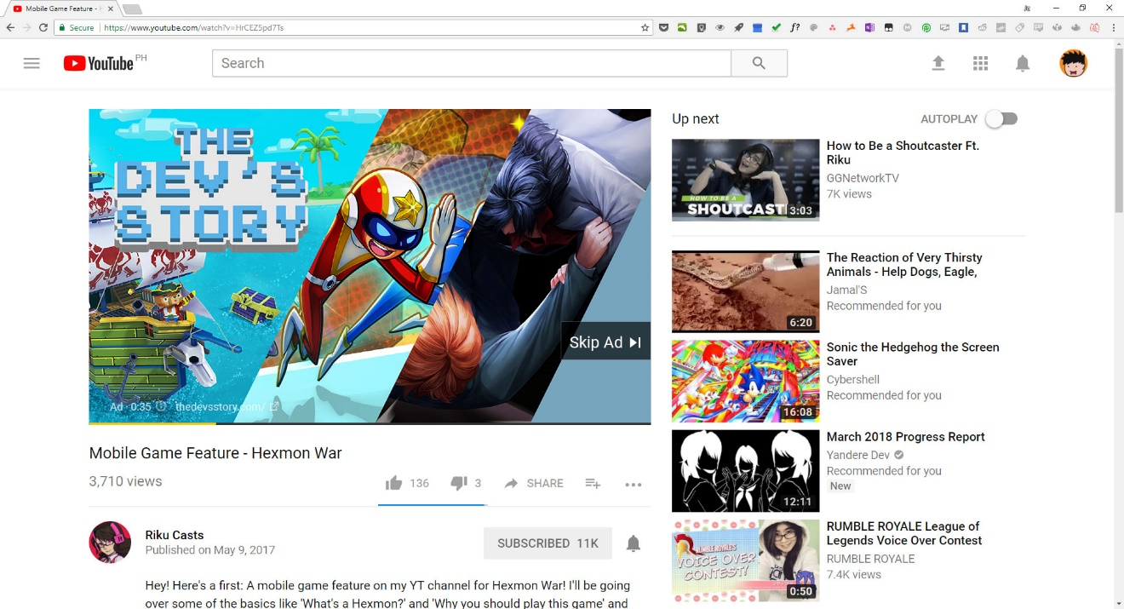

Website Ad Sample

